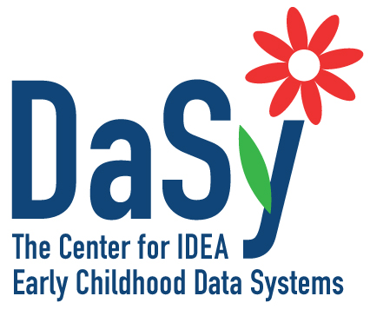
Early Childhood
Data System Framework
May 2013

Partner State Overview

Purpose

The DaSy Center is inviting applications from Part C and Part B 619 state agencies to become one of four to six partner states that will assist the DaSy Center in developing an Early Childhood (EC) Data System Framework. The framework will identify components of an effective early childhood data system and include quality indicators for each of the components. The EC Data System Framework, accompanied by a self-assessment and additional resources, will be designed to guide states in evaluating their current Part C and 619 data systems and identifying areas for improvement. The framework will highlight features that promote coordination across systems and longitudinal capabilities that allow linking data about children and programs over time. The DaSy EC Data System Framework will complement frameworks already being used or being developed by other organizations, such as the Early Childhood Outcomes (ECO) Center, the State Longitudinal Data System (SLDS) Support Team, and the Early Childhood Technical Assistance (ECTA) Center.

Benefits of Being a Partner State

State partners will have the opportunity to:

- Participate in a collaborative learning opportunity with the DaSy Center, other national experts, and colleagues from other states focused on components of a quality EC data system;
- Build state capacity related to understanding what it means to have a quality EC data system;
- Explore the strengths and challenges of their current state data system(s), and gain access to resources and strategies for improvement; and
- Learn about strengths, challenges, and approaches in other state data systems from interacting with representatives from other partner states who are actively improving their own data systems.

Application Requirements

Each state’s application to participate as an EC Data System Framework partner state with the DaSy Center must include:

- A completed application (one page)
- Statements of commitment signed by the Part C Coordinator and the Part C Data Manager and/or the 619 Coordinator and the Part B Data Manager, and others as determined by the state
- Optional supplemental letters of commitment from other agencies or organizations in your state
In addition to submitting the application package, Part C and/or Part B 619 Coordinator must complete the DaSy TA questionnaire. The link to this online survey was sent to all state Part C and 619 Coordinators on May 20, 2013.

Responsibilities of Being a Partner State

Each partner state will engage in this activity for approximately 1 year (June 2013–August 2014) with the DaSy Center and other state colleagues to develop an EC Data System Framework designed to guide Part C and Section 619 programs in evaluating and improving their state EC data system(s). State partners will work closely with the DaSy Center to develop and disseminate the framework and self-assessment by:

- Describing existing components of their state’s EC data system(s).
- Providing input on decisions regarding which components are critical to include in the framework.
- Collaborating in the development of quality indicators and evidence statements for the data system components.
- Reviewing and providing feedback on draft materials related to the data framework and self-assessment.
- Involving key state staff and other individuals in the state with expertise and experience in specific areas, as needed.
- Supporting the DaSy Center in sharing updates about the framework on national webinars and/or conferences.
- Committing to participation in this effort for a period of approximately 1 year.
- Participating in monthly conference calls with DaSy Center and state colleagues.
- Attending up to four in-person meetings in Washington, DC over the course of the year (travel and per diem expenses to be covered by DaSy).

Potential Collaborators (Optional, but encouraged)

Are there others in your state with expertise and experience in specific areas who can be involved, as appropriate, in this initiative? For example, you may want to include others on conference calls or in reviewing and providing input on draft materials. Some examples of other sectors who might be involved include Child Care, Head Start, Early Head Start, State Pre-K, Race to the Top–Early Learning Challenge Coordinator, Early Childhood Advisory Council (ECAC) Executive, a key Parent Organization, etc. If so, please identify other staff/collaborators you could involve, and ask them to sign a letter of commitment. Make extra copies of the letter as needed.

Selection Criteria

We are looking for states with strengths in different aspects of data system development/management and data reporting/use. We will select a group of states to represent different geographic areas, a range of population sizes, and for Part C, different Lead Agencies. Preference will be given to states where both Part C and Part B Preschool jointly participate in DaSy framework activities and who demonstrate a strong level of commitment from other key players in their state.

Submission Information

Application process:
- We are asking that the Part C and 619 Coordinators and the Part C and Part B Data Managers decide together about interest in participating in the DaSy EC Data System Framework development.
- We encourage both Part C and 619 to apply together, but one or the other may apply alone. A minimum partnership would be the Part C Coordinator and Part C Data Manager together, or the 619 Coordinator and the Part B Data Manager together.
- Please select one individual to submit the application to DaSy. The response to the application questions should reflect the thinking across the pair or group of individuals applying. Electronic signatures or scanned pages of signed documents are acceptable.
- Please submit the application response and all of the relevant statements of commitment in one e-mail to donna.spiker@sri.com.
- If you have any questions about being a partner state or the application process, contact any of the following individuals:
  - Kathy Hebbeler (530-758-7483 or kathleen.hebbeler@sri.com)
  - Donna Spiker (650-859-6184 or donna.spiker@sri.com)
  - Lynne Kahn (919-962-2781 or lynne.kahn@unc.edu)

Application and signed letters of commitment must be submitted by June 14, 2013 via e-mail to Donna Spiker at:
donna.spiker@sri.com

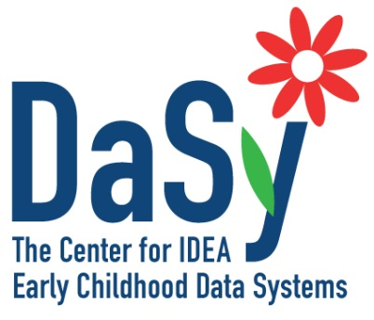
DaSy EC Data System
Framework

Partner State Application
State: Click here to enter text.

What are the strengths in your state related to early childhood data systems?

Some examples of possible state strengths:
- Have you successfully linked individual child data across several early childhood programs?
- Were you able to develop interagency agreements that meet the regulations and data needs of different agencies?
- Does your state have an effective data governance body that includes Part C and/or 619 in a meaningful way?
- Does your data system include a variety of types of data, e.g., child assessment data, data on program quality, professional development, or billing/fiscal data?
- Has early childhood played a major role in your SLDS grant?
- Is building a longitudinal coordinated data system a priority of your state early childhood advisory council?

Please limit your response to 300 words.

Click here to enter text.

Please return this page and all signed commitment pages to
donna.spiker@sri.com by June 14, 2013

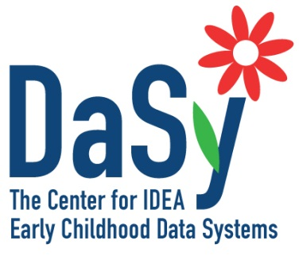
Framework Partner State Application

Statement of Commitment

Part C Coordinator

Responsibilities of Being a Partner State

Each state partner will engage in this activity for approximately 1 year (June 2013–August 2014) with the DaSy Center and other state colleagues to develop an EC Data System Framework designed to guide Part C and Section 619 programs/systems in evaluating their state’s data capacity, through a self-assessment, and to improve their data system. State partners will work closely with the DaSy Center to develop and disseminate the framework and self-assessment by:

- Describing existing components of their state’s EC data system(s).
- Providing input on decisions regarding which components are critical to include in the framework.
- Collaborating in the development of quality indicators and evidence statements for the data system components.
- Reviewing and providing feedback on draft materials related to the data framework and self-assessment.
- Involving key state staff and other individuals in the state with expertise and experience in specific areas, as needed.
- Supporting the DaSy Center in sharing updates about the framework on national webinars and/or conferences.
- Committing to participation in this effort for a period of approximately 1 year.
- Participating (most likely) in monthly conference calls with DaSy Center and state colleagues.
- Attending up to four in-person meetings in Washington, DC over the course of the year (travel and per diem expenses to be covered by DaSy).

By signing this statement of commitment, I indicate my interest in becoming a DaSy Center partner state for data system framework development.

Part C Coordinator: State: Click here to enter text.
Name: Click here to enter text.

Signature Date

Framework Partner State Application

Statement of Commitment:

Part C Data Manager

Responsibilities of Being a Partner State

Each state partner will engage in this activity for approximately 1 year (June 2013–August 2014) with the DaSy Center and other state colleagues to develop an EC Data System Framework designed to guide Part C and Section 619 programs/systems in evaluating their state’s data capacity, through a self-assessment, and to improve their data system. State partners will work closely with the DaSy Center to develop and disseminate the framework and self-assessment by:

- Describing existing components of their state’s EC data system(s).
- Providing input on decisions regarding which components are critical to include in the framework.
- Collaborating in the development of quality indicators and evidence statements for the data system components.
- Reviewing and providing feedback on draft materials related to the data framework and self-assessment.
- Involving key state staff and other individuals in the state with expertise and experience in specific areas, as needed.
- Supporting the DaSy Center in sharing updates about the framework on national webinars and/or conferences.
- Committing to participation in this effort for a period of approximately 1 year.
- Participating (most likely) in monthly conference calls with DaSy Center and state colleagues.
- Attending up to four in-person meetings in Washington, DC over the course of the year (travel and per diem expenses to be covered by DaSy).

By signing this statement of commitment, I indicate my interest in becoming a DaSy Center partner state for data system framework development.

Part C Data Manager: State: Click here to enter text.
Name: Click here to enter text.

Signature Date

Framework Partner State Application

Statement of Commitment:

Part B 619 Coordinator

Responsibilities of Being a Partner State

Each state partner will engage in this activity for approximately 1 year (June 2013 – August 2014) with the DaSy Center and other state colleagues to develop an EC Data System Framework designed to guide Part C and Section 619 programs/systems in evaluating their state’s data capacity, through a self-assessment, and to improve their data system. State partners will work closely with the DaSy Center to develop and disseminate the framework and self-assessment by:

- Describing existing components of their state’s EC data system(s).
- Providing input on decisions regarding which components are critical to include in the framework.
- Collaborating in the development of quality indicators and evidence statements for the data system components.
- Reviewing and providing feedback on draft materials related to the data framework and self-assessment.
- Involving key state staff and other individuals in the state with expertise and experience in specific areas, as needed.
- Supporting the DaSy Center in sharing updates about the framework on national webinars and/or conferences.
- Committing to participation in this effort for a period of approximately 1 year.
- Participating (most likely) in monthly conference calls with DaSy Center and state colleagues.
- Attending up to four in-person meetings in Washington, DC over the course of the year (travel and per diem expenses to be covered by DaSy).

By signing this statement of commitment, I indicate my interest in becoming a DaSy Center partner state for data system framework development.

Part B 619 Coordinator: State: Click here to enter text.
Name: Click here to enter text.

Signature Date

Framework Partner State Application

Statement of Commitment:

Part B Data Manager

Responsibilities of Being a Partner State

Each state partner will engage in this activity for approximately 1 year (June 2013–August 2014) with the DaSy Center and other state colleagues to develop an EC Data System Framework designed to guide Part C and Section 619 programs/systems in evaluating their state’s data capacity, through a self-assessment, and to improve their data system. State partners will work closely with the DaSy Center to develop and disseminate the framework and self-assessment by:

- Describing existing components of their state’s EC data system(s).
- Providing input on decisions regarding which components are critical to include in the framework.
- Collaborating in the development of quality indicators and evidence statements for the data system components.
- Reviewing and providing feedback on draft materials related to the data framework and self-assessment.
- Involving key state staff and other individuals in the state with expertise and experience in specific areas, as needed.
- Supporting the DaSy Center in sharing updates about the framework on national webinars and/or conferences.
- Committing to participation in this effort for a period of approximately 1 year.
- Participating (most likely) in monthly conference calls with DaSy Center and state colleagues.
- Attending up to four in-person meetings in Washington, DC over the course of the year (travel and per diem expenses to be covered by DaSy).

By signing this statement of commitment, I indicate my interest in becoming a DaSy Center partner state for data system framework development.

Part B Data Manager: State: Click here to enter text.
Name: Click here to enter text.

Signature Date

Framework Partner State Application

Supplemental Statement of Commitment (optional)
By signing this statement of commitment, I indicate the interest of my agency/organization to work with my State Part C and Part B Section 619 programs if they are selected as a DaSy Center partner state for data systems framework development.

State: Click here to enter text.
Agency/Organization: Click here to enter text.

If selected, we will engage in a collaborative learning opportunity with the DaSy Center, other national experts, and colleagues from other states to develop a framework for developing a quality early childhood data system that includes and benefits Part C and Section 619. More specifically, if requested we will:

- Discuss and plan with others in my state about current data system capacity and plans, approaches, and issues associated with making improvements.
- Provide input on decisions regarding which components are critical to include in the framework.
- Review and provide feedback on draft materials related to the framework and self-assessment.
- Participate in conference calls with DaSy Center and state colleagues as requested.
- Attend in-person meetings over the course of the year, if requested, as part of my state team (travel and per diem expenses to be covered by DaSy).

Name: Click here to enter text.
Position: Click here to enter text.
E-mail: Click here to enter text.

Signature Date

